Design Document

**I·**List of project directory structure:

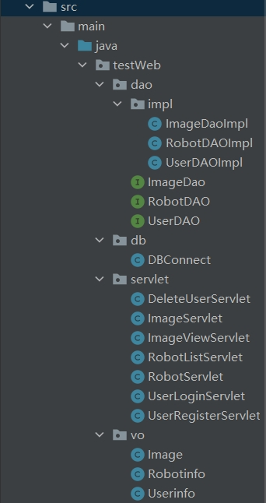

**·**Overview of Tools and Technologies Used:

Frontend page design involves technology: html+css+layui.

Backend development and design technology: JSP+servlet+JavaBean+jdbc+dao.

Server and Java version: Tomcat8.5 java19.

Development and debugging tools: Intellij idea 2021.1.2 Chrome MySQL Navicat

**II·**Design of Robot Management System Database:

(1)Selection of Database Management Systems and Database Visualization Tools:

Database management system: MySQL database management system

Database visualization tool: Navicat for MySQL

(2) Creation of databases and tables in databases:

A database called Javawebdb has been established in MySQL to store information related to tables in this system. The ID is used as the primary key and is set to automatically increment

i.userinfo table:

Username: The username of the user account

Password: The password of the user account

ii.robotinfo table:

The userinfoid field in this table references the id in the userinfo table as a foreign key

Rbname: the name of the robot.

Exploreavgtime: average exploration time of robots.

Rbtype: the type of robot.

iii.imagefile table:

Cdate: upload time.

Start_time: the time start explore.

End_time: the time end explore.

Book: number of books explored.

Key: number of keys explored.

Cubee: number of cubees explored.

**III·**Display and explanation of directory structure for finished product projects:

The project follows the design of a three-layer architecture for soft armor development. The presentation layer (servlet, JSP, web browser, etc.) is used to display data, the business layer (service) is used to handle business requirements, and the persistence layer (dao) is used to complete interaction with the database

Here are a few examples of classes:

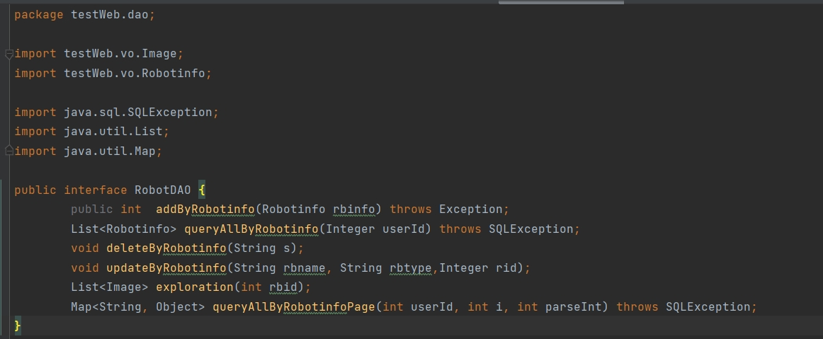

RobotDAO interface: Defined various methods related to robots

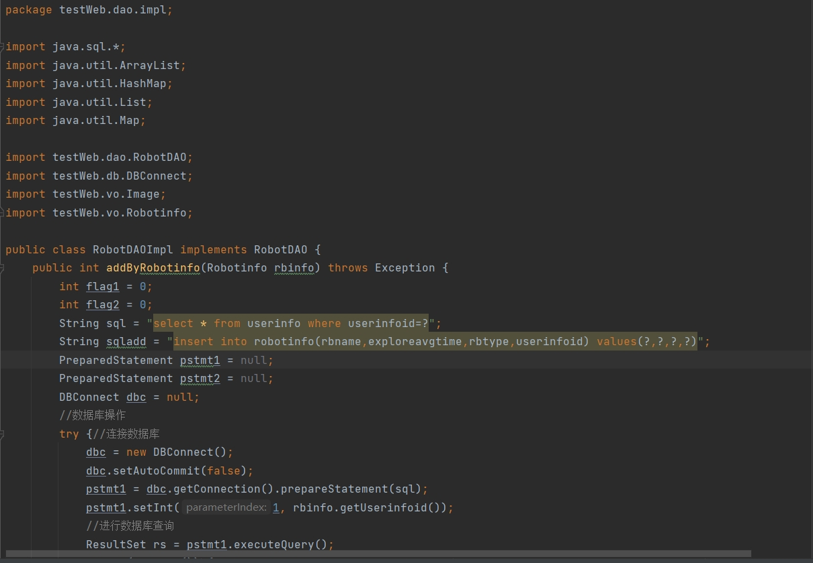

RobotDAOImpl Class:

Functionality: The RobotDAOImpl class is responsible for adding, storing and querying robot information. It also can show robot exploration.

Interface Implementation: This class implements the RobotDAO interface, providing methods for adding robot information and querying robot data for specific users.

Database Connection: Similarly, it establishes a database connection by instantiating the DBConnect class.

DBConnect class: Connect to the database by building a DBConnect instance

RobotListServlet class:

Functionality: Implement the doGet method: Process GET requests sent by the client.

Obtain the parameter 'method' in the request to determine the specific operation requested by the client.

Obtain the userId of the current user and obtain the user's identity from the session.

Create a RobotDAO instance to access robot information in the database.

Perform different operations based on the requested method parameters

Robotinfo class:

Functionality: there are the value used to store in the database.

Web design:

We use a front-end framework called layui for web design, a free and open source web ui component library. We used the layui framework to build a backend management interface.The page has functions such as layout, menu management, and tabs through layui.

Thanks for your read!!!